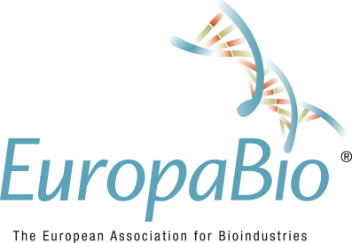

EuropaBio: Biomanufacturing and pharma legislation in the spotlight at the BIO International Convention 2023

NEWS RELEASE
Brussels, May 2023 – EuropaBio flies the flag for European biotechnology at the highly anticipated BIO International Convention 2023, scheduled to take place in Boston, MA on 5-8 June and one of the largest biotech industry events worldwide with 100+ interactive sessions across 4 days covering all aspects of business, policy, trade and science.
EuropaBio plays a key role at BIO, with its National Associations Council bringing company and policy maker delegations, highlighting pharma legislation in Europe, acting as a global focal point for biomanufacturing and working within the European delegation from the European Commission and European Medicines Agency.
EuropaBio also holds the Vice Chair of the International Council of Biotech Associations (ICBA), and the annual meeting during BIO will being together the global biotech family.
EuropaBio Director-General Dr. Claire Skentelbery said: “BIO is always the perfect place to get European biotech business done on a global scale. We attend with members and key stakeholders for Europe and connect with partners and policymakers worldwide for the advancement of biotech everywhere. This year is critical with the publication of the pharma legislation and we are also delighted to be bringing the Biomanufacturing Platform to BIO for the first time”.
On June 4, EuropaBio’s Director General Dr Claire Skentelbery will participate in the International Council of Biotechnology Associations (ICBA) Annual Meeting. The ICBA is a coalition of non-profit, national biotechnology trade associations that work together to foster public understanding and advocate for policies that facilitate the growth of innovative biotechnology industries. Dr Skentelbery is the Vice Chair of ICBA since 2022.
On June 5 (10:30 - 11:30 EDT), EuropaBio hosts a round-table discussion on "Biomanufacturing for health: advancing healthcare and global preparedness". Global biomanufacturing stakeholders will discuss national policies, incentives, and strategy, regulatory alignment, and international cooperation. Following the roundtable, a call to global action for biomanufacturing will be issued and published through EuropaBio and BIO.
From 13:00 – 14:00 EDT on the same day, EuropaBio is co-hosting a round table in collaboration with EUCOPE. The round table will focus on the new European pharmaceutical landscape and aims to provide valuable insights and information for pharmaceutical companies planning to launch their products in the EU.
During the evening, Dr Claire Skentelbery will moderate the European Night reception, which networks the European family together in the US.
On June 7 (16:15 – 17:15 EDT) EuropaBio is part of the roundtable on “BioPharma & Bio Manufacturing: Changing the Narrative and Addressing Climate Challenges”.
More information, the list of speakers and registration are here.
Are you interested in meeting EuropaBio’s representative at BIO International Convention in Boston? Please get in touch with Dr Claire Skentelbery, Director General, EuropaBio.

ENDS

Media contact
Alexandra Simionca, Communications & Visual Design Coordinator
Email: a.simionca@europabio.org
About EuropaBio
EuropaBio, the European Association for Bioindustries, promotes an innovative and dynamic European biotechnology industry. EuropaBio and its members are committed to the socially responsible use of biotechnology to improve quality of life; to prevent, diagnose, treat, and cure diseases; to improve the quality and quantity of food and feedstuffs and to move towards a biobased and zero-waste economy. EuropaBio represents corporate and associate members, plus national biotechnology associations and bioregions. Read more about our work at www.europabio.org.

